

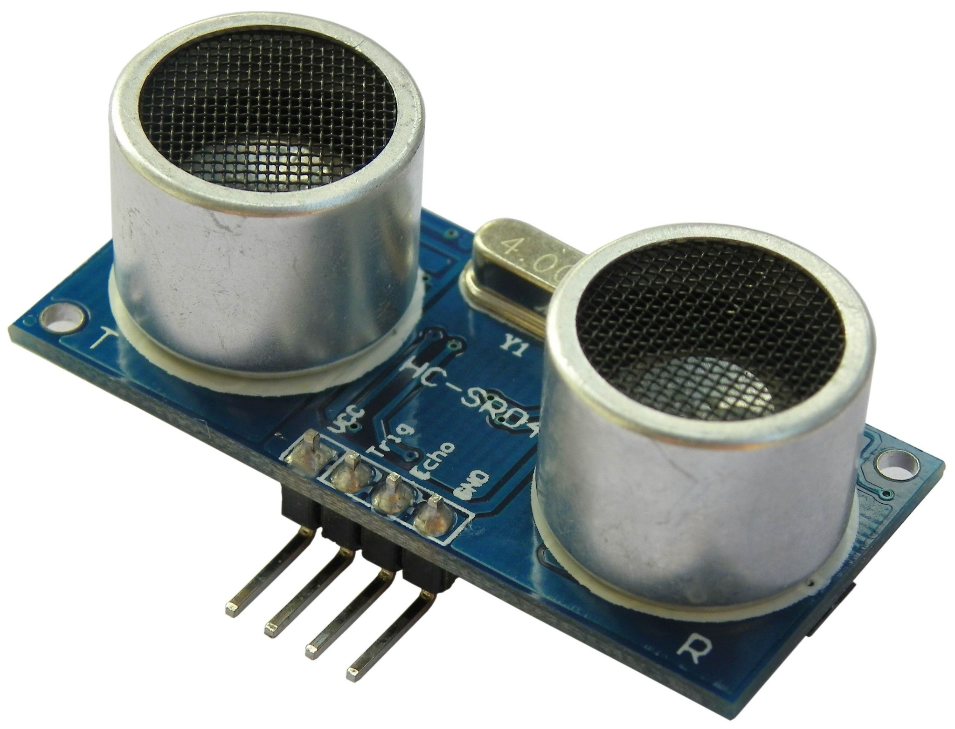

**User's Manual**

**V1.0**

**May 2013**



**Index**

1. Introduction  3
2. Packing List  4
3. Product Layout 5
4. Product Specification and Limitation  6
5. Operation  7
6. Hardware Interface 8
7. Example Code  9

1. Warranty 10

**1.0 INTRODUCTION**

The HC-SR04 ultrasonic sensor uses sonar to determine distance to an object like bats or dolphins do. It offers excellent non-contact range detection with high accuracy and stable readings in an easy-to-use package. From 2cm to 400 cm or 1” to 13 feet. It operation is not affected by sunlight or black material like Sharp rangefinders are (although acoustically soft materials like cloth can be difficult to detect). It comes complete with ultrasonic transmitter and receiver module.

**Features:**

* Power Supply :+5V DC
* Quiescent Current : <2mA
* Working Currnt: 15mA
* Effectual Angle: <15°
* Ranging Distance : 2cm – 400 cm/1" - 13ft
* Resolution : 0.3 cm
* Measuring Angle: 30 degree
* Trigger Input Pulse width: 10uS
* Dimension: 45mm x 20mm x 15mm

**2.0 PACKING LIST**

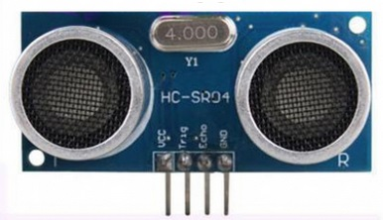

1. 1 x HC-SR04 module

**3.0 PRODUCT LAYOUT**

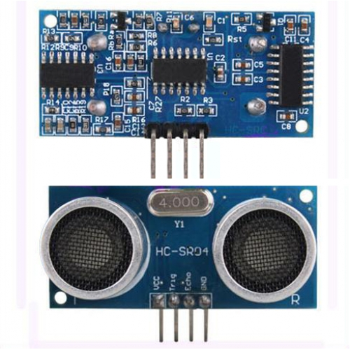

VCC = +5VDC

Trig = Trigger input of Sensor

Echo = Echo output of Sensor

GND = GND

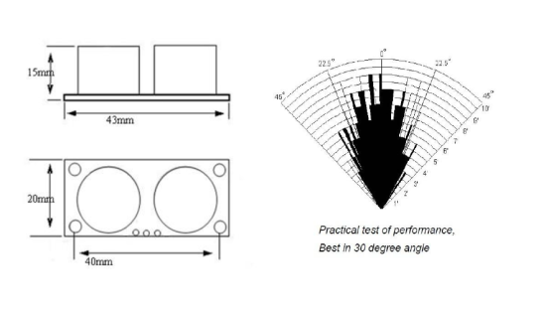

**4.0 PRODUCT SPECIFICATION AND LIMITATIONS**

| **Parameter** | **Min** | **Typ.** | **Max** | **Unit** |
| --- | --- | --- | --- | --- |
| Operating Voltage | 4.50 | 5.0 | 5.5 | V |
| Quiescent Current | 1.5 | 2 | 2.5 | mA |
| Working Current | 10 | 15 | 20 | mA |
| Ultrasonic Frequency | **-** | 40 | **-** | kHz |

**5.0 OPERATION**

The timing diagram of HC-SR04 is shown. To start measurement, Trig of SR04 must receive a pulse of high (5V) for at least 10us, this will initiate the sensor will transmit out 8 cycle of ultrasonic burst at 40kHz and wait for the reflected ultrasonic burst. When the sensor detected ultrasonic from receiver, it will set the Echo pin to high (5V) and delay for a period (width) which proportion to distance. To obtain the distance, measure the width (Ton) of Echo pin.

Time = Width of Echo pulse, in uS (micro second)

* Distance in centimeters = Time / 58
* Distance in inches = Time / 148
* Or you can utilize the speed of sound, which is 340m/s

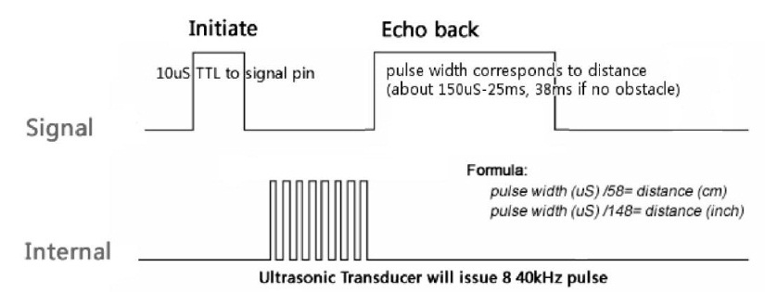

| Note:   * Please connect the GND pin first before supplying power to VCC. * Please make sure the surface of object to be detect should have at least 0.5 meter2 for better performance. |
| --- |

**6.0 HARDWARE INTERFACE**

Here is example connection for Ultrasonic Ranging module to Arduino UNO board. It can be interface with any microcontroller with digital input such as [PIC](http://www.cytron.com.my/listProductGroup.php?pid=GykHJTAIICMjCiUOKzUrAFr6E7ywlpBPhdZ6UvIVjnI=), [SK40C](http://www.cytron.com.my/viewProduct.php?pcode=SK40C&name=Enhanced%2040%20pins%20PIC%20Start-Up%20Kit), [SK28A](http://www.cytron.com.my/viewProduct.php?pcode=SK28A&name=28%20Pins%20PIC%20Start-up%20Kit), [SKds40A](http://www.cytron.com.my/viewProduct.php?pcode=SKDS40A&name=40%20Pins%20dsPIC%20Start-Up%20Kit), [Arduino series](http://www.cytron.com.my/listProductGroup.php?pid=Ox8tGxAKJyUZAx0JMQoWL/ikd9PKGf2H2v1OHG9I3gk=).

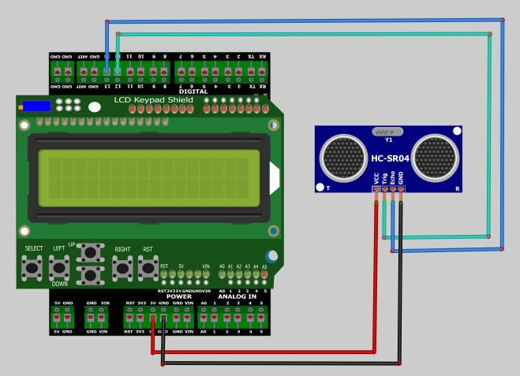

**7.0 EXAMPLE CODE**

This is [example code](http://www.cytron.com.my/usr_attachment/HC_SR4_Demo_Arduino.zip) Ultrasonic Ranging module. Please download the complete code at the product page.

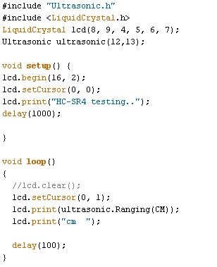

**8.0 WARRANTY**

* Product warranty is valid for 6 months.
* Warranty only applies to manufacturing defect.
* Damaged caused by miss-use is not covered under warranty
* Warranty does not cover freight cost for both ways.

*Prepared by*

***Cytron Technologies Sdn. Bhd.***

19, Jalan Kebudayaan 1A,  
 Taman Universiti,  
81300 Skudai,

Johor, Malaysia.

*Tel: +607-521 3178*

*Fax: +607-521 1861*

*URL:* [www.cytron.com.my](http://www.cytron.com.my/)

*Email:* support@cytron.com.my

sales@cytron.com.my